Fire Sport - UK www.firesport.com
Hosted by East Sussex Fire & Rescue Service ~ Communications by RAYNET

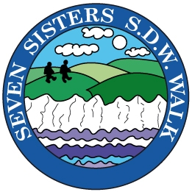
Saturday 3rd June 2017

Seven Sisters

South Downs Way Walk
FIRE SPORT UK ~ LDWA ~ & OPEN TO ALL

A Classic Walk in the South Downs National Park

Choose from: 8.7, 15.3, or 25.3 miles routes
Entry Fee just £10 (£5 U16) and includes a Medal to all finishers
Start/Finish at Eastbourne, University Sports Complex Denton Road BN20 7SR

For more details visit: www.firesport.com or email ludomacaulay@hotmail.com

